Name: Ugochukwu Achara
Class: MSBA 653
Prof. Brittany Green
Exercise One
EDA (Using R)
Preview the dataset
- head(HeavenlyChocolatesInClass)
Summary of all variables
- summary(HeavenlyChocolatesInClass)
Standard deviation for numeric vars
- sapply(HeavenlyChocolatesInClass[, sapply(HeavenlyChocolatesInClass, is.numeric)], sd)
Check for missing values and duplicated values
- colSums(is.na(HeavenlyChocolatesInClass))
- sum(duplicated(HeavenlyChocolatesInClass))

Step 1
Frequency Tables for categorical tables (Day)
Count
- table(HeavenlyChocolatesInClass$Day) 
Probability
- prop.table(table(HeavenlyChocolatesInClass$Day)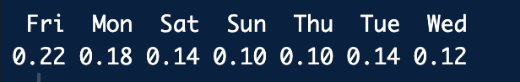

Step 2
Relationship plot – Scatterplot showing positive correlation between Time and Amount
- HeavenlyChocolatesInClass |>
ggplot(aes(x = Time, y = `Amount Spent`)) +
geom_point() +
theme_minimal()

Step 3
Relationship plot – Amount spent by day faceted by Browser
- HeavenlyChocolatesInClass |>
ggplot( aes(x = Day, y = `Amount Spent`)) +
geom_boxplot() +
facet_wrap(~Browser) +
theme_bw() +
labs(title = "Amount Spent by Day (faceted by Browser)")

The plot shows that Amount Spent is highest on Fridays and Mondays regardless of browser although most site visitors use Chrome browsers as opposed to Firefox and other browsers. Most of the sales is generated from the Chrome users on the above stated days so marketing efforts should focus on maximizing channels that are already showing promise. Target marketing efforts to Chrome users compared to any other browsers. If the funds available allow then Firefox users as well and make sure inventory and site infrastructure is calibrated to meet the heavy traffic through the weekends.

Exercise Two
Fit multiple linear regression using the same data as exercise 1 which is the Heavenly chocolates In class dataset also located below or in the python lab: linear regression. The goal is to predict amount spent. Provide important variables and business recommendations.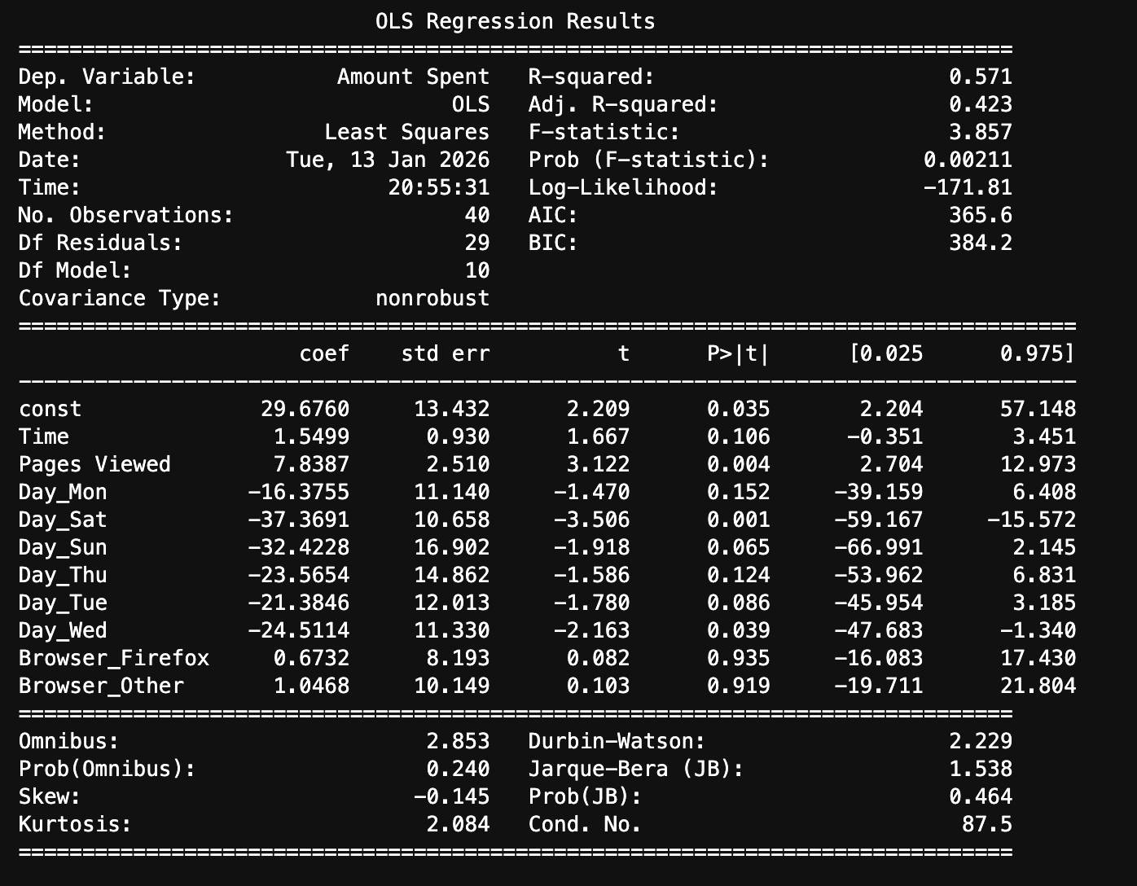

Predictions
Y_predictions = linreg_pipe.predict(X_test)
print(Y_predictions)

Time, pages viewed and days (Saturday and Sunday) are the significant variables. The business should increase site engagement to maximaize the time that patrons spend on the site as well as pages viewed as these would most likely lead to a purchase. The business can also have promotions that would attract patrons to the site on low spending days which is everyday other than the weekend. They can also run SEO to increase site visibility on other browsers other than Chrome and Firefox

